CMR TECHNICAL CAMPUS
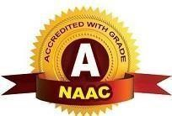
UGC AUTONOMOUS
Accredited by NBA & NAAC with ‘A’ Grade
Approved by AICTE, New Delhi and JNTU Hyderabad

Department of Computer Science and Engineering
Future of Loan Approvals with Explainable AI


The project on the "Future of Loan Approvals with Explainable AI" envisions a transformative approach to the loan approval process by incorporating Explainable Artificial Intelligence (XAI). This project explores the integration of advanced AI models that not only assess creditworthiness but also provide transparent explanations for their decisions. The incorporation of XAI enhances the fairness, accountability, and trustworthiness of loan approval systems, paving the way for a more inclusive and transparent future.

  Modern banking systems process thousands of loan applications daily. Manual evaluation is slow and inconsistent, while traditional automated systems lack transparency.  This project proposes an intelligent loan approval system that:  - Automates loan approval prediction  - Identifies reasons for loan rejection  - Provides explainable decision insights  - Reduces human bias  - Enhances decision transparency  The application uses a graphical interface built with Tkinter, allowing users to upload datasets, preprocess data, train models, and predict loan approval outcomes.  Explainable AI visualization helps financial analysts understand why a loan was approved or rejected. | 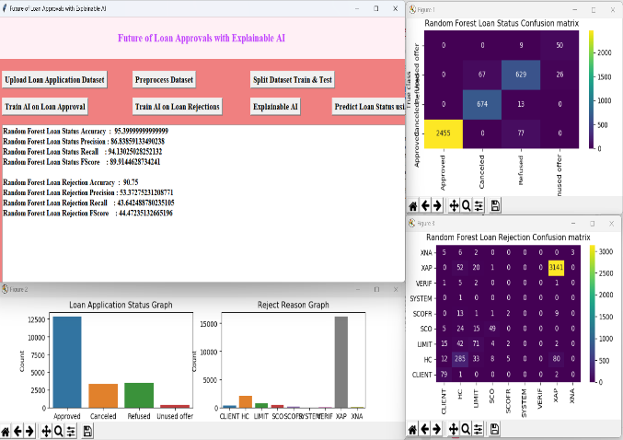  OUTPUT:
 | Batch-21:  SK. IRFAN 247R1A05C2  A. VINAY 247R1A0568  B. VIGNESHWAR 257R5A0507  FACULTY SUPERVISOR  Ms. G. Swati, Assistant Professor.
- Manual verification by officers
- Rule-based decision systems
3. Traditional machine learning models
4. Black-box AI systems without explanations
5. Time-consuming document evaluation
In conclusion, the "Future of Loan Approvals with Explainable AI" project envisions a future where loan approval decisions are not only accurate but also transparent and understandable. By embracing Explainable AI, the project aims to set new standards for fairness, accountability, and trust in the loan approval process.

